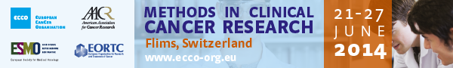

Bautista Paco – France  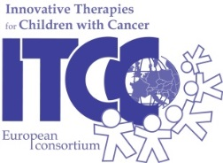  Supported by Society ITCC | 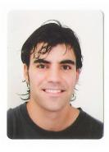 | Institut Gustave Roussy  Paediatric Oncology  Villejuif  France

FLIMS MEMORIES
Flims is one of the most beautiful places I have ever been. Before FLIMS 16, I even did not know where Flims was. I now know it is in Switzerland, and since now and onwards, also in my best memories. Flims means beauty, nature and adventure. FLIMS 16 means work, endless effort, sacrifice, and restless days; but it also means friends, team spirit, self-esteem and satisfaction. I went to FLIMS 16 with an idea, and I came back home with my first protocol. During those days I worked hard to write this protocol up. Nevertheless this would have never been possible without the help and input of my group faculty and co-students. The master-classes were outstanding and helped me to learn how to develop a well-structured clinical trial. Finally, the organization was really good and even the smallest detail was taken into consideration. My protocol is a basket trial where paediatric patients with relapsed or refractory tumours that harbour particular molecular alterations will receive targeted agents directed toward these alterations. It is an innovative design where the drugs will be given at the 100% of the adult recommended dose in an enriched population of patients. This protocol will permit to confirm the recommended dose in paediatrics and evaluate efficacy in one study, in order to speed the drug development process in children. In conclusion, I am very happy with this experience and sure that it will be very helpful for my professional career. I would strongly recommend this course to my colleagues interested in clinical research and clinical trials.

